Chapter no. 6

כותרת בצבע כחול crt +

טקסט בצבע שחור ctrl 0

הערת שוליים בצבע ירוק ctrl . נקודה

כותרת משנה C 2

Mother's wish

As told[1] by the Chabad *shaliach* of Antwerp, Rabbi Shabtai Slavaticki, who heard it from his father-in- law Rabbi Chazan from London:

A non-observant Jewish couple living in the United States had not been blessed with children. They had gone to many doctors and undergone various treatments, yet all to no avail. After several years, however, the wife did became pregnant.

During a routine check-up in her sixth month, the physician noticed a serious complication and told her that were she to give birth to the baby, she would have no chance of survival.

When she told her husband the sad news, he assumed that there was no choice but to abort the pregnancy, yet she refused, declaring that she would rather give up her own life to save her child. After so many years of prayers and treatments and dreams of having Jewish family, she could not now, finally blessed with a child, forfeit its life for her own.

She gave birth to a healthy baby boy and died in labor.

When the boy matured, the father did not wish to reveal to him the circumstances of his mother’s death, so he told him that his mother died when he was two from an illness.

Years passed, and the boy, now a young man in university, met a girl and decided to get married. He announced the news to his father, who asked for details about his fiancée. When his father heard that the girl wasn’t Jewish, he expressed sorrow and disappointment. The son was surprised, telling his father that he had always raised him on liberal views. “Why should this suddenly be an issue?” he wanted to know.

“Because we’re Jews!” he said, and told him how much that identity had matter to his mother. Perhaps it was too little or too late, but in any case, it had little effect on his son.

When the wedding day arrived, the young man’s father asked him to go with him to his mother’s grave. There at the gravesite, he revealed the true circumstances of her death and the self-sacrifice of his mother to have a Jewish child who might, in turn, build a Jewish family of his own.

After his shock subsided, the son asked his father to wait for him outside the cemetery. A half-hour later he joined him and said, “I promised Mom her dream would come true.”

He called his fiancée and called off the wedding. Some time later, he found a Jewish girl and married.

“I Was Born a Jew, and I shall die a Jew.”

**the story of Sulikah “Sul” Chajuel**

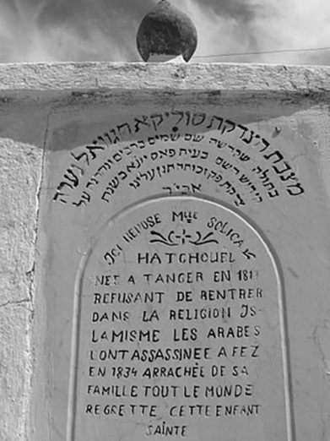The Jews of Islamic nations, like their European brethren, bravely clung to their religious beliefs despite powerful national pressure to forsake their traditions. Of the many stories bearing testimony to their struggles is the tale of Sulikah Chajuel, a young Jewish woman who readily gave up her life rather than abandon her faith.

Sulikah “Sul” Chajuel (1817-1834) was a Moroccan Jewish girl whose father Chaim, a merchant and Torah scholar, cultivated within her a firm Jewish identity and an unshakable faith in Hashem.

She was extraordinarily beautiful, and according to the research of Israel Yosef Binyamin, a Jewish traveler who visited Morocco in the mid 1900’s, her Muslim neighbors regarded her as a stunning “pearl.” “What a shame that such a pearl is to be found amongst the Jews!” they would say. “How wrong it would be to allow such a jewel to remain with them!” And indeed, according to one community member’s diary account, Sulikah was friends with a young and very devout Muslim girl who claimed to have finally won her over to Islam and convinced her to convert.

That friend’s claim, though fantasy at best, and the community’s sentiment that she was too precious to remain with the Jews reflected a pervasive environment of religious coercion, one amidst which the regional governor eventually ordered her arrest on the basis of a single, fabricated testimony that she had “rebelled” against Islam.

The governor assured her that should she agree to convert, she would be well protected from her parents and community and even generously rewarded with gold and fine silks. Yet if she would resist abandoning her faith and, as such, incur the wrath of the Prophet Muhammed, he promised that she would be bound in chains, imprisoned in a pitch-black dungeon, starved, and publically executed, her remains to be discarded and eaten by wild animals.

Sulikah was defiant. “I would gladly bear the weight of chains,” she told him, “and I don’t care if I never again see the light of day. Let me be starved, killed, and devoured. And as for your prophet’s wrath, since both he and yourself seem powerless to compel a mere girl of seventeen, I doubt that I’ll have much to worry about in the hereafter.”

Sulikah’s neck, hands, and feet were then bound in heavy irons, and she was imprisoned in a windowless cell. Her parents desperately sought the aid of the Spanish consulate general, who exhausted every effort to free her, but to no avail. The governor decided to send her to the city of Fez, where the sultan would determine her fate. There, the leader and his advisors tried convincing her to convert. The sultan’s son, taken by her beauty, urged her to embrace Islam. Even the rabbinate of Fez’s Jewish community pleaded with her to at least outwardly convert so that she might escape such a violent and tragic death. She refused them all, insisting, “I was born a Jew, and I shall die a Jew.”

The sultan commanded that Sulikah be decapitated in the public square of Fez. One account describes the atmosphere in the square that day as being filled with both anticipation, as the Islamic fanatics eagerly awaited the spectacle, and profound dread and despair, as the city’s Jews helplessly looked on.

The sultan instructed his executioner to slowly inflict pain upon the girl before delivering the final blow in the hopes that her resolve might finally break and she would submit to conversion, but Sulikah bore it all, declaring even in her agony that she would never forsake the Torah of Moshe and Israel. “Don’t detain me,” she challenged her torturer. “Cut off my head now, in one blow! For in as much as I shall die free of wrongdoing and guilt, the G-d of Avraham will surely avenge my death!”

After her death, Sulikah became known amongst the Jews as “Sul the righteous woman,” and amongst the Arabs, themselves ultimately affected by her martyrdom, she was called “Sulikah the holy woman.” Her grave became a place of worship, and Jews would pilgrimage there from great distances in order to pour out their hearts to Hashem at the holy site. Her epitaph reads in French: “Here lies Mademoiselle Sulikah Chajuel. Born in Tangier in 1817, she refused to adopt the Islamic religion, and the Arabs killed her, torn from her family, in Fez in 1834. The entire world mourns her death.”

Divorcing the Shiksa

The Jewish "Chain"

Some words I wrote regarding *Mivtza Tefillin* in the summer of 5775 (2015):

When we reached the Amitai base next to Rafiach in the afternoon, I met a soldier who was sitting next to his room, playing a guitar. We spoke about melodies, etc., and I taught him the *nigun* of Reb Michele of Zloczow. He liked the melody, and he also put on tefillin.

Afterwards, he said, “Can I ask you a question?” “Of course,” I answered. “What do you think of messianic Jews?”

From my experience, these questions don’t usually come out of nowhere. I wondered why he was asking, and he told me that his girlfriend was connected to such a cult and was pressuring him to join. Her mother, a Dutch gentile, had undergone an orthodox conversion, but she is very active in this cult, and she had also dragged her Husband, the girl's father, (an Israeli), into it.

We sat together for a long time. I told him that Christianity had, among other things, led to the Holocaust. I explained that his girlfriend was not Jewish because her mother was not a Jew (apparently, in spite of the orthodox conversion), and he, who came from many many generations of Jews, should be particularly careful not to break the chain.

He asked why he had been given such a difficult test, and I answered with the famous story about the *shliach* Rabbi Shabtai Slavaticki of Antwerp. (This is a similar story about a man who wanted to marry a non-Jewish woman, and Rabbi Slavaticki brought him to the Rebbe. The Rebbe told this Jew, “I am jealous of you that you should have such a test, because it means that you have the strength to overcome it.” After that, the Jew cried a lot and then decided to leave his non-Jewish girlfriend.)

Though it was very hard for this soldier to accept all of this, he did not want to leave me and he sat with me in my car afterwards and I gave him a booklet to read.

I hope and believe that as we are *shluchim* of the Rebbe, even when it doesn’t seem that we have had any immediate success, in any case we act with the power of the *meshalayach* … (Until here, this is what I wrote [Translation from Hebrew] in my report to "Ohr Lechayal" - Chabad in the IDF).

Afterwards, I called Rabbi Yoav Ze'ev Robinson, from "Yad Lachim". After much effort, persuasion, and reading material, and a Shabbat invitation from Yoav, the soldier left his non-Jewish girlfriend. Rabbi Yoav told me that the soldier composed a sad song about the whole story.

A year or more later, I met the soldier. He was very happy and thanked me for the help. We haven't met since, but in his WhatsApp status, he is seen with a kippah sitting and studying *Gemara.* (Talmud)

Conversions in the IDF

A lot of pressure has been put on converting IDF soldiers from Russia and Ukraine.

. In June 2017, Stanislaw Yurovsky appealed to the Supreme Court against the IDF. He claimed that since he was drafted, he has suffered insults connected to the fact that he has not Jewish, and has been told repeatedly to convert. He added that every few weeks, his commanding officers suggested he should convert because “conversion would improve his life in Israel because it is better for the Jews here.” The soldiers claim that anyone who does not cooperate and does not attend ceremonies that are held every year is treated accordingly. In fact, it is not really conversion. The IDF holds many courses: officer training, cooking, driving, and so forth, and also conversion courses, where Hebrew and knowledge of Israel is taught, along with how to live as a Jew. The course is offered as a compromise to the Reform, Conservative, and Orthodox movements, and some of the teachers are Reform.

I met a soldier who went through an army conversion course in Elon Moreh. He explained that his paternal grandfather was a Jew but all the rest of his family were non-Jews. As his parents did not want to convert, he was worried about the next generation. If he married a non Jewish woman, their children would not be Israeli citizens. (According to the law, he would be the last generation in the family to receive citizenship because his grandfather was Jewish.) Therefore, he was now taking the course.

I met another soldier at a pillbox in the southern Hebron 26 Hills in *Elul* 5777, who, when I asked him about putting on tefillin, told me he was currently undergoing conversion. “Through *Nativ*?” I asked. He answered in the affirmative, and said that he intended to continue with the conversion course. When I asked him why, he said that he was not that interested in Judaism, but if he did not convert and had a civil marriage, his marriage would not be recognized and he would only be considered as a single man. One thing was clear. He was not interested in Judaism. He also repeated the issue of civil rights. Ninety-eighty percent of those who take the IDF course do not keep even the main *mitzvahs*, such as Shabbat. Even though *halachic*, the “converts” are not Jews, they are treated in Israel (regarding marriage, etc.) as if they are Jews!

Reformed conversion

Most of the problems of fictive conversions around the world, are done by Reform "rabbis". The "rabbi", who may have only had a Jewish grandfather, sells Judaism for 50 dollars... I had the "honor" to meet such a "rabbi".

When writing this book, (the Hebrew edition) I traveled to the area of Mevo Shilo, to the base run by the *Nachal Hachareidi*. I was supposed to be giving a *shiur* there. On the way, in the valley leading to the area, usually a very quiet place, I noticed from a distance an army jeep blocking the way, with a crowd gathered around it.

When I got closer, I saw a group of strange-looking people, Jews and non-Jews, led by an American Reform "rabbi". They were wildly trying to push soldiers out of the way to create a provocation that would lead to a response, to be filmed of course. I got out of my car and hurried over to the place. As soon as I arrived on the scene, they left the soldiers and turned their cameras on me and the weapon I was carrying.

The reason for the gathering was that a Reform "rabbi" had said the hilltop youth had attacked the local Arabs the previous day. So here was one of the hilltop youth – a *Chabadnik* with a white beard... And so they took a lot of pictures with several cameras so that the whole world could see who the hilltop youth were with all of their Jewish paraphernalia.. Afterwards, when an officer arrived on the scene, the provocateurs claimed that the soldiers had attacked them. They told outright lies, the films were edited, and the end became the beginning. And so, before long, I received what they had published on the Internet about me and the IDF soldiers with regard to what happened there.

When I heard the words of the "rabbi", who was even wearing a very small *kippah*, and I saw his wild behavior, I understood that the war against real Judaism, to which the Reform have devoted themselves, goes together with the war against the Jews.

Rabbi Shmuel Lew

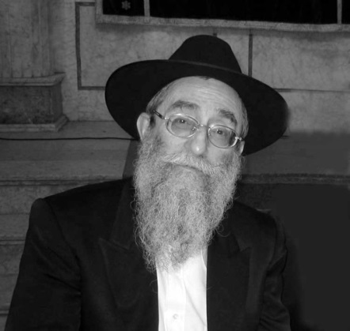

A Special League

Rabbi Shmuel Lew and his wife are the Rebbe’s shluchim in London. In an interview with JEM, the Chabad media company, Rabbi Lew spoke (among other topics) about their first steps as emissaries:

There was a music student at the Royal College whom I met at various occasions. He began to visit me regularly. This was during the years when I focused mainly on students. We spent much time studying and talking about Judaism and we became close to each other.

At one point he got involved with a non-Jewish girl and a strong connection developed between them. She was a devout Christian and she tried to influence him in religious matters.

‏When he visited me, he would ask certain questions without telling me what lay behind them, and I tried to answer him. In the end he decided to reveal everything and he told me that he was deeply involved with this relationship. At that time I was not too familiar with dealing with such cases, but I did have some experience. So I asked him to come to my house to talk about it.

When he arrived, I told him, “Dave, you belong to a special league. More religious, less religious, we are working on it; all of the Torah’s commands are infinite. But now you want to take a critical step away from the Jewish religion, and to have children who are not Jewish, so you owe yourself a clarification of what you know and what you do not know.’ “I added: Look, there are hundreds of books in this room, maybe a thousand, fifteen hundred. Can you read a single line in one of these books?

He said: ‘No.’

Finally I told him he should go to the Lubavitcher Rebbe for the forthcoming festival of Purim and meet the Rebbe in a private audience.

‏He went to New York and saw the Rebbe. Before entering the Rebbe’s room, it was customary to write a note as short as possible, containing the main points about what they wanted to talk about. The Rebbe would read the note and then discuss the topics accordingly. In his note, the student wrote out all of his theological questions but he did not mention anything about the girl.

‏The Rebbe read the note quickly and said: “Mixed marriages are something harmful. It will hurt you; it will hurt the young woman; and worst of all - it will hurt the innocent children born in these marriages.”

The student who knew that no one had reported to the Rebbe about his connection with the non-Jewish girl realized that this was a clear case of prophetical vision. However, he was not the shy type and he said to the Rebbe: “This question is not listed in the note.”

The Rebbe replied: “That’s the key to the questions.”

‏He asked: ”What do you suggest I should do?”

The Rebbe replied: “Go and learn in a Yeshivah.”

He said: “Rabbi Lew told me to learn six weeks in a Yeshivah.” The Rebbe replied: “Six weeks - it’s not enough. Go for six months!”

“And what about my career and everything else?”

The Rebbe replied:” A Yeshivah is not a prison. Go, and if you feel it’s good for you, stay”.

‏And he went to the Yeshivah, studied there and later married. He now lives in Israel, has children and grandchildren, and lives according to the Torah and its commandments.

This young man was an only child who came from the provinces in northern England. When he returned from his stay with the Rebbe, his father phoned me and said: “Thank you for returning my son to me!”

Turning Bitter into Sweet

A group of Yeshivah students who studied in the Lubavitch Yeshivah in 770 Eastern Parkway, (World Chabad Center in New York) once made preparations with a certain Jewish man to arrange a big Purim party in his house, including the reading of the Book of Esther. They had got to know this person during their outreach work when they put on *tefillin* with people on a regular basis every Friday.

The man invited many friends to his house for the Purim party and everybody was ready for this happy event, which was to be filled to capacity with Chassidic energy and warmth.

The Yeshivah boys went to sleep at a late hour the night before, and in the morning they did not wake up on time… Neither did the food that they planned to bring with them arrive on time. But they did not give up hope and set off for the man’s home-despite the fact that they realized that they had caught the wrong train on their way and were further delayed.

In the meantime 20-30 people were waiting at the host’s house until they gave up on the party at a certain point and left.

When the boys finally arrived, there was nobody there except for the host and his wife. The man looked insulted and offended. His wife was screaming loudly: “Who needed this party in the first place? What a shame that you invited these Yeshivah boys and all your friends!” She added another few invectives that the boys did not understand.

The boys returned to 770 in low spirits. They asked themselves over and over again: “Why did this happen to us? Especially on the day of Purim, the happiest of all festivals!”

During the following days they were still unable to find the answer.

Friday came. The boys went on their usual round, laying tefillin. This time they were somewhat apprehensive about meeting the host of the party that wasn’t, and they did not know how to excuse themselves for the unpleasant incident.

When they entered the man’s business, he seemed to be in a good mood. When he noticed the boys, he approached them and shook their hands with warmth, his face radiating with joy. He told them: “In the merit of your ‘party,’ I left my non-Jewish wife!”

It turned out that his wife was so aggravated by what had happened that she did not stop for a moment besmirching the Jews, their commandments, and their festivals.

“I did not remain quiet and I gave her back a double portion. The fight went on and on until we finally decided to part one from the other.”

In the merit of the party that did not take place, the man felt able to leave his non-Jewish wife and he later on married a Jewish woman in accordance with the Jewish faith.

**A Clandestine Marriage Ceremony**

*Based on the journal of the Rebbe’s mother, Rebbetzin Chana Schneerson.*

*The following story happened in the USSR in 1935, a time when Soviet oppression was at its peak, and the KGB was tracking all Jewish activity that was defined as “counterrevolutionary, anti-government.”*

One night, at 11 pm, a knock was heard on the door of Rabbi Levi Yitzchak Schneerson, the Chief Rabbi of the city of Dnepropetrovsk. An older woman entered the apartment. She looked around nervously to make sure that there was no one there besides the rabbi and his family.

“Rabbi,” she whispered. “I have come from a distant city that I cannot identify by name. In another hour, at midnight, my daughter and son-in-law will be here too. They are both serving in high-level government positions; coming here is fraught with danger for them. It was only after I begged and pleaded with them to go to a rabbi who would arrange a proper Jewish wedding for them that they promised me they would. But they set the condition that the wedding ceremony would take place in your home, honored Rabbi, and nowhere else. I came in advance to give you time to prepare for their arrival.”

At exactly midnight, the couple arrived. They were immediately brought into a side room so that no one would see them. The rabbi began to prepare for the marriage ceremony. First, he needed to get a *minyan* (quorum of ten adult Jewish males). By now it was after midnight. The streets were empty, deserted; not a living creature could be seen. Where would it be possible to get another eight - aside for the rabbi and groom - to compete a *minyan* at this hour?

The marriage needed to take place that night at any cost. A delay could not be afforded. It was necessary to get eight “kosher” Jews - people that could be relied upon to keep a secret and not tell anyone what they had seen. Otherwise, the lives of the rabbi, the young couple, and everyone present would be in danger.

Within half an hour, the room held nine men. Only one was missing, a tenth man for the *minyan*.

What did the rabbi do?

In Rabbi Levi Yitzchak’s apartment building, a young Jew had been assigned by the government to serve as head of the housing committee. It was his responsibility to spy and keep careful tabs on any irregular movements in the home of the rabbi and verify that no religious ceremonies were taking place.

It was to him that the rabbi sent a messenger, asking him to come.

When he arrived, Rabbi Levi Yitzchak told him that he wanted him to serve as the tenth man of a *minyan*, so that he could conduct a Jewish wedding for the young Jewish couple that was getting married that night.

“Me?!?” He jumped back as if bitten by a snake.

“Yes, you!”

The young man rushed to the windows, closed all the shutters. Then he sat down quietly and alertly watched the unfolding events.

The rabbi’s wife brought a big tablecloth to serve as the *chuppa* (canopy), and four of those present, like living posts, held up its four corners.

When the *ketubah* (marriage contract) was drawn up, the bride and groom were summoned from their hiding place in the other room. The bride’s face was veiled and the groom tried to cover his face, too, so he wouldn’t be recognized.

The ceremony began. No candles were lit due to the bride and groom’s fear of discovery. Seven circles were conducted around the groom as is customary, the rabbi arranged the marriage and recited the seven blessings. The groom put the ring on the bride’s finger and said, “Behold you are betrothed to me....” The ceremony was complete.

It was now 1:30 am. The bride and groom hurried to vacate the premises, as did all the other participants - except for two.

These were people who held Communist Party cards. They took their cards out of their pockets, approached Rabbi Levi Yitzchak, and said emotionally:

“As of now, Rabbi, we are with you and we do not want to part from you. All of this” - pointing to their cards - ”is worth nothing to us when we are with you, honored Rabbi...”

A Jewish Wedding in Sweden

Rabbi Alexander Namdar, the Rebbe’s *shaliach* in Gothenburg, Sweden, was invited to speak to the city’s Reformed Jewish community. He was cautioned, however, that should he accept, there was a list of sensitive subjects which could not be broached. Shabbos, for example, was a no-no. Mentioning all of those restrictions and limitations would only make people uncomfortable. Kashrus, too, was off-limits. The health benefits of Judaism’s dietary laws notwithstanding, telling people what they can and cannot eat would only alienate. The list went on but, interestingly enough, made no mention of intermarriage, so the Rabbi accepted.

The event took place in the synagogue’s beautiful, spacious social hall. From the podium, the president cordially introduced the evening’s guest speaker and even thanked him for having graciously consented to keep his words of encouragement and inspiration within certain “appropriate guidelines.”

Rabbi Namdar rose and approached the microphone with a smile and a respectful nod that seemed to say, “You are quite welcome.” He scanned the audience with his warm, embracing eyes. Everyone sat, comfortably waiting, curiously taking in his black hat and very long, somewhat graying beard.

“Thank you so much for hosting me,” he began. “And I would like to sincerely thank the president and the community for allowing me to address a particular topic which is truly of the utmost importance to us all as Jews. I would like to speak about intermarriage.”

The smile fixed across the president’s face vanished. A ripple of protest ran through the room. Some began reaching for their coats. Others glared at the president threateningly. “Did he say intermarriage?” many wondered out loud, incredulous.

“It is absolutely forbidden,” Rabbi Namdar continued, undeterred, “for a Jewish man or a Jewish woman to marry a non-Jew...” People began heading for the exits.

“Under no circumstances whatsoever…” he went on, but his words were lost in the ruckus.

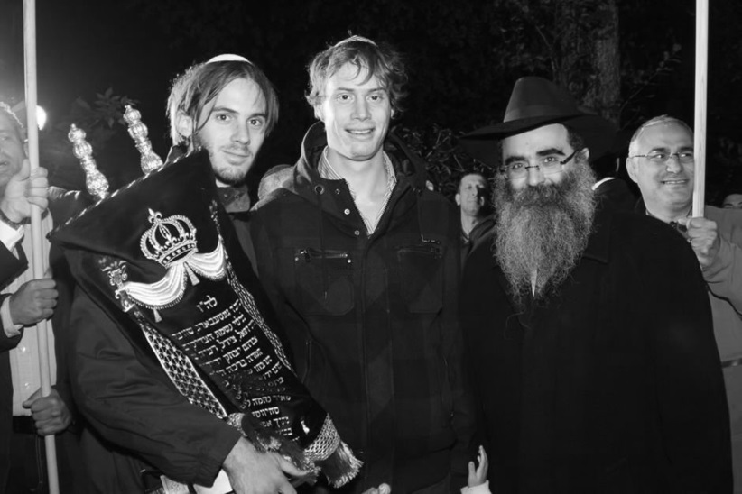

Rabbi Namdar at a Sefer Torah inauguration at the Chabad House in Gothenburg, *together with members of the Schijveschuurder family, who donated* the Sefer Torah in memory of their parents and three siblings, who were killed in the 2001 Sbarro restaurant terror bombing in Jerusalem.

Rabbi Namdar had made quite an impression upon Gothenburg’s Reformed community. Many were aghast. Many were resentful. And many couldn’t help but be struck by his courage and resolve. They knew that he was fully aware of the minefield he was walking into, but he stood there, looked everyone squarely in the eyes, and laid bare a very raw issue. They were as impressed as they were unsettled, and they went home and told their children what they had seen and heard. And perhaps because they were not cynical, but excited, even disbelieving, like someone truly affected and moved, the rabbi’s message struck a lasting cord within at least two of those young people as well.

Soon after the incident, a young man of Gothenburg sat, heavyhearted, with his new girlfriend. Though they had only recently met, he was very taken with her and had hoped that a special relationship would develop. Yet now, he had something to tell her. “I never thought that it would be an issue for me,” he said, “but it’s become an issue. Just recently.” He paused and breathed deeply. “I’m Jewish, and I don’t think I can be with someone who isn’t Jewish.”

“I honestly never thought that this would matter to me,” he apologized, trying to console her, but then, he saw that she was smiling. And then laughing. And then laughing uncontrollably.

“This has got to be the craziest moment of my life,” she said, trying to catch her breath. “I came here tonight to tell you the same thing!”

“What same thing?” he asked, struggling to make sense of the conversation.

“That I’m Jewish,” she said, laughing again, “and that I don’t think I should be with someone who isn’t Jewish!”

Both had heard from their parents about Rabbi Namdar’s speech that night, about what an absolute tumult it had caused in the community, and both had made the unlikely decision to take his words to heart. And here they now stood, ready to follow through with their new commitment and give up something dear, yet finding instead something more precious than they could ever have imagined.

It did not take long for them to grow, together, in Jewish observance and, ultimately, stand beneath the *chuppah* as *chasan* and *kallah*… with, of course, Rabbi Namdar officiating.

מכאן מכתבים@@

The Difference between Israel and the Nations—from speeches of the Rebbe

...This being said, it is clearly understood just how ridiculous it would be for someone to come and say that a non-Jew could be a Jew or that a Jew could be a non-Jew. If the Holy One, Blessed-be-He, the Creator and Conductor of the Universe distinguished between Israel and the other nations, no one can change this distinction. Even if the “wisest” and “most knowledgeable” individual (as he considers himself) dislikes this distinction, or even if he is completely indifferent to the fact that there will be disorder and destruction in the entire world!... G-d established boundary and distinction between Israel and the other nations, and decreed in His Torah that when a non-Jew expresses his desire to convert, “he is asked, ‘what did you see that brought you to convert?’” (Maimonides, Laws of Forbidden Entrances, beginning of chap. 14). Additionally, it is necessary to detail for him all the difficulties involved in order to prevent him from converting. Only after it is evident that despite all of the adversity he is convicted to converting—only then is he converted according to the Torah’s laws, “the word of G-d, this is The Law.”

Though it is true that this man was originally created as a non-Jew, never-the-less, G-d Himself declares that when this man completes the process of conversion according to G-d’s will as established in His Torah, Halachic conversion, then G-d gives him a Jewish soul. Just as there is no question how G-d creates a soul, so too, there is no question or wonder about how G-d is able to remove the life-force of a non-Jew and to give him a Jewish soul. However, no action apart from a halachic conversion can effect this transformation of a non-Jew into a Jew. This is impossible. On the contrary, a person who was born a Jew or who converted according to Jewish law will remain Jewish forever and ever—this is true even if he does not desire this, G-d forbid! As it says in the Talmud: “even though he sinned, he is Israel!” Regardless of his behavior, he remains a Jew, the son of G-d! Rather G-d gave him the choice to act as a Jew or the opposite, G-d forbid, with faith that when he contemplates with normal, human intellect, he will certainly conclude that as a Jew it is incumbent upon him to act as a Jew acts—and he will come to this understanding out of his own good will without need for “police”... who will hold him with force and prevent him from killing himself by jumping into the river!... And even if, G-d forbid, he does not chose to act as a Jew—after everything G-d does not give up on any Jew.

The only question if his decision will be immediate or if it will take some time, G-d forbid, and meanwhile he will distress himself, the Jewish people and the entire world, may G-d prevent this. With regards to all of this, there is an explicit halachic decision in Maimonides (who was the “Guide for the Bewildered” of his and all generations) in his encyclopedia of laws *Yad Hachazaka*:  a) A Jew is one who was born to a Jewish mother or who converted according to Jewish law, as explained by Maimonides in the laws of conversion. b) A Jew who announces that he desires to act in contradiction to Jewish law, in contradiction to the instructions of the Jewish court is forced to conduct himself according to Jewish law. It is considered as though he has done this “by his will.” The explanation for this is that since he is a Jew his true and internal will is certainly a “will to be part of Israel, and he desires to uphold all the commandments.” What happened? “His evil inclination overpowered him,” and therefore “he is beaten until his evil inclination is weakened and he says I want to do the right thing.” We say that this is “according to his will.” In other words, a Jew remains a Jew his entire life, and even when behaving in an inappropriate manner, G-d forbid, this is only a covering of “dust” or “mud.” Once this covering is removed or cleaned, his true existence is revealed in its purity.

In the Continuation of the Talk:

When a non-Jew sees the conduct of a Jew who is a “fake” non-Jew his whole life, he believes that he has become a Jew. This is at a time when the Lord of Israel clearly and unambiguously established in the Torah (as every observant Jew knows) that he remains a non-Jew just as he was from the beginning! There is nothing that can cause more hatred to the Jewish people than the news that a Jew tries to “trick” and to “mislead” the non-Jew. And in what manner? Not in food or drink, clothing or other physical things—that in these things it is also forbidden by Torah law (pertaining to every single Jew beginning with Moshe Rabbeinu who received the Torah on Mount Sinai and until the final generation, since the Torah is eternal) that it is **forbidden** to steal **even less than the equivalent of a few cents;** what is more, he “deceives” him for the course of his entire life with something that is close to his heart by saying that from this day on he is considered a son of the People of Israel. This is at a time when the Creator and Conductor of the Universe decreed once and for all that so long as a person does not convert according to Jewish law he remains a son of the same nation from which he came![2]

Assimilation and Intermarriage - “The Final Solution”

From the perspective of Jewish commitment and identity, intermarriage is one of the most serious sins, affecting one’s entire life. Furthermore, even though this has always been the case, it is especially relevant during our present generation. The Holocaust has left a special legacy for all of the Jews who survived to prevent such a thing from reoccurring. Our enemies have two ways of trying to destroy the Jewish people: one is by physical destruction, as the Nazis were trying to do, and the other is more sophisticated, but of no lesser degree of annihilation. This is through assimilation, and especially intermarriage, G-d forbid.

One must also remember that no one lives in an ivory tower, and nobody can claim that his life is his personal business. When the foundations of Jewish identity are being destroyed by a single Jew, this will no doubt affect the environment, since other people may follow his example and behave in a similar manner. This chain reaction will inevitably accelerate the “final solution.”

By keeping in mind that Jews throughout our history - in all places and conditions and under every possible pressure - still maintained their uniqueness and did not marry Gentiles, this gives the person involved the power and courage to stand firm and overcome the trial of not marrying a non-Jewish partner. Every Jew today is undoubtedly a descendant of generations upon generations that kept up this uniqueness with self-sacrifice and were unwilling to be swallowed up 5 between the nations under any circumstance. This self-sacrifice held true whether it was during times of persecution or times of plenty when they were invited and pressured to intermarry, and this is despite the fact that the Jewish people was always the “fewest of all the nations.” The merit of the forefathers and mothers throughout the generations will certainly assist all those who wish to follow their path and avoid breaking the golden chain.[3]

Honor and respect

When[4] a non-Jew sees a Jew who is not ashamed of his Jewishness, but he actually declares it openly, with ”the pride of Yaakov,” that he is a member of the Jewish nation and is following in the footsteps of his father, his grandfather, and great-grandfather, and so forth, this arouses a feeling of honor and respect towards the Jew. Hisvaaduyos 5745, vol. 2, page 1042

הבא@ הועתק גם בפרק חמישי וצ"ע היכן להשמיט

The Children of Israel It is well-known to everyone around the world, even the nations of the world, that the existence, strength and power of the Children of Israel is founded and rooted within the fathers and mothers of this nation. It is an inheritance from them to every single man and woman among the sons and daughters of Israel, and like the nature of our souls, in every time and place. This is what makes us one single division within the world: “It is a nation that will dwell alone and will not be reckoned among the nations.”[5]

Conversions in the IDF

A lot of pressure has been put on converting IDF soldiers from the CIS. In June 2017, Stanislaw Yurovsky appealed to the Supreme Court against the IDF. He claimed that since he was drafted, he has suffered insults connected to the fact that he has not Jewish, and has been told repeatedly to convert. He added that every few weeks, his commanding officers suggested he should convert because “conversion would improve his life in Israel because it is better for the Jews here.” The soldiers claim that anyone who does not cooperate and does not attend ceremonies that are held every year is treated accordingly. In fact, it is not really conversion. The IDF holds many courses: officer training, cooking, driving, and so forth, and also conversion courses, where Hebrew and knowledge of Israel is taught, along with how to live as a Jew. The course is offered as a compromise to the Reform, Conservative, and Orthodox movements, and some of the teachers are Reform. I met a soldier who went through an army conversion course in Elon Moreh. He explained that his paternal grandfather was a Jew but all the rest of his family were non-Jews. As his parents did not want to convert, he was worried about the next generation. If he married a non Jewish woman, their children would not be Israeli citizens. (According to the law, he would be the last generation in the family to receive citizenship because his grandfather was Jewish.) Therefore, he was now taking the course. I met another soldier at a pillbox in the southern Hebron 26 Hills in Elul 5777, who, when I asked him about putting on tefillin, told me he was currently undergoing conversion. “Through Nativ?” I asked. He answered in the affirmative, and said that he intended to continue with the conversion course. When I asked him why, he said that he was not that interested in Judaism, but if he did not convert and had a civil marriage, his marriage would not be recognized and he would only be considered as a single man. One thing was clear. He was not interested in Judaism. He also repeated the issue of civil rights. Ninety-eighty percent of those who take the IDF course do not keep even the main mitzvahs, such as Shabbat. Even though most halachic authorities today do not recognize these “converts” as Jews, they are treated in Israel (regarding marriage, etc.) as if they are Jews.

The Reform Movement

When writing about conversions and Jewish status, one cannot fail to mention – even in this publication – the Reform movement. Shluchim around the world are more familiar with their slanders than I am, yet in any case it is worthwhile reading the lines below: When writing this book, I traveled to the area of Mevo Shilo, to the base run by the Nachal Hachareidi. I was supposed to be giving a shiur there. On the way, in the valley leading to the area, usually a very quiet place, I noticed from a distance an army jeep blocking the way, with a crowd gathered around it. When I got closer, I saw a group of strange-looking people, Jews and non-Jews, led by a self-styled Reform 'rabbi'. They were wildly trying to push soldiers out of the way to create a provocation that 27 would lead to a response, to be filmed of course. I got out of my car and hurried over to the place. As soon as I arrived on the scene, they left the soldiers and turned their cameras on me and the weapon I was carrying. The reason for the gathering was that a Reform rabbi had said the hilltop youth had attacked the local Arabs the previous day. So here was one of the hilltop youth – a Chabadnik with a white beard... And so they took a lot of pictures with several cameras so that the whole world could see who the hilltop youth were with all of their Jewish paraphernalia.. Afterwards, when an officer arrived on the scene, the provocateurs claimed that the soldiers had attacked them. They told outright lies, the films were edited, and the end became the beginning. And so, before long, I received what they had published on the Internet about me and the IDF soldiers with regard to what happened there. When I heard the words of the rabbi, who was even wearing a very small kippah, and I saw his wild behaviour, I understood that the war against real Judaism, to which the Reform have devoted themselves, goes together with the war against the Jews.

The Effects of Intermarriage

As Jews, we should first of all look at intermarriage from the viewpoint of the Torah, which is a teaching for life and a guide for every Jew. The Torah is the true source of life, not only in the next world but also in this physical world. Since this standpoint might seem to be of less importance to people who are dispersed among Jews and non-Jews, a number of points are brought here, expressed within general human concepts:

1) Statistics have sufficiently proven that mixed marriages are one of the greatest disasters in existence, not only for the Jewish partner but also for the non-Jewish partner. Since the two come from such different backgrounds, an intermarriage will be a source of constant friction and agony. The disaster becomes even greater if they have children who will grow up in a home torn by such frictions.

Furthermore, statistics show only the “tip of the iceberg,” because many cases are not reported, and nor do they attract public attention. Additionally, many of the statistics are not published because they are accessible only to those who come into contact with these cases personally, such as doctors, rabbis, attorneys, etc., all of whom are committed to secrecy.

In addition, the parties directly involved in mixed marriages are often too ashamed to admit their mistake and they do their best to conceal the friction and daily sorrow that they have brought upon themselves, especially if they were forewarned about the consequences and preferred to ignore these warnings.

2) The statistics are not so surprising. Actually, it would have been astonishing if the results had shown otherwise, when you take into consideration that not only do both sides come from different backgrounds, as explained above, but also from hostile backgrounds, with generations upon generations of persecution from one side and victims from the other.

3) When you look into the disastrous results, it is difficult to understand why there are mixed marriages at all. However - and this is understandable - the parties directly concerned are so tempted and so full of emotive feelings that self-deception and wishful thinking, fed by a strong connection and strong physical emotions, take the place of common sense and simple logic.

4) There may be a special emotional bond between opposites. However, when taking into account all of the hostile elements, this emotional bond cannot last long because sooner or later all of the hatred and hostility will float to the surface. These will gradually grow stronger, as each side accuses the other for getting him into such a complicated situation.

5) One of the most common arguments for the protection of “justice” and “freedom” in intermarriage is that since both parties are adults and are ready to bear the consequences, etc., no one has the right to intervene and interfere.

It is enough to use one simple example to show the fallacy of this argument. Imagine a person standing on a bridge ready to throw himself off and put an end to his life. He claims that he knows what he is doing, and no one has the right to intervene, etc. Obviously, in a civilized society, anyone nearby would try to discourage this person from carrying out his intention, and if necessary, call the police and the fire services to prevent this attempted suicide by all means in order to save him from hurting himself.

6) If there was any real feeling between the two, not to mention simple decency and honesty, neither would want to involve the other in such a predicament - even if the chances for problems seem slim. But as already noted, there are some very reasonable causes for concern (and even inevitable ones) that mixed marriages will end in disaster, both physically and spiritually. Even if some of these couples do seem to be happy and satisfied, very likely this is no more than an outer facade to prevent their embarrassment from being known to others.

If a Jewish man marries a non-Jewish woman, in addition to the destruction that he brings upon himself and upon his partner, he brings devastation upon his children, because children born to a non-Jewish mother are not Jewish.

The Merit and the Obligation to Battle Assimilation

Blessings and Greetings,

I’d like to confirm that I received your letter of April 5th.

I was glad to see that you agree with me regarding the necessity of doing away with what’s commonly referred to as ‘dialogue.’

I trust that you will continue to fight against intermarriage, as you have for so many years. Needless to say, as much as has been accomplished in this area, it is not nearly enough to stop this evil. Even were we talking about just a single incident of intermarriage, one would be obliged to invest every possible effort to bring it to an end, since even an isolated case involves more than just one person; it affects his children and grandchildren, his relatives and his friends, as well. All the more so [are we thus obliged] in light of the ever-increasing number of incidents. Your efforts in battling this evil are a great merit, as well as an urgent obligation of the highest priority.

In our confused generation, it is unfortunately necessary to address the following additional matter: the popular yet unfounded opinion that the problem of intermarriage can be solved by conversion. In addition to the fact that this is not a creative solution by any means, the very possibility [that conversion can be manipulated toward this end] is itself even more destructive, from several angles. The only conversion that has any validity is one that follows the laws laid down in the *Shulchan Aruch*, the same source which forbids intermarriage in the strongest terms.

There is an additional baseless opinion which maintains that if we speak the whole truth in this matter, we are apt to chase people away and thereby lose them. In actuality, however, the only ones who end up chasing people away are those who lack the courage to tell the truth, for people are always more deeply impressed when they hear the full, unadulterated truth.

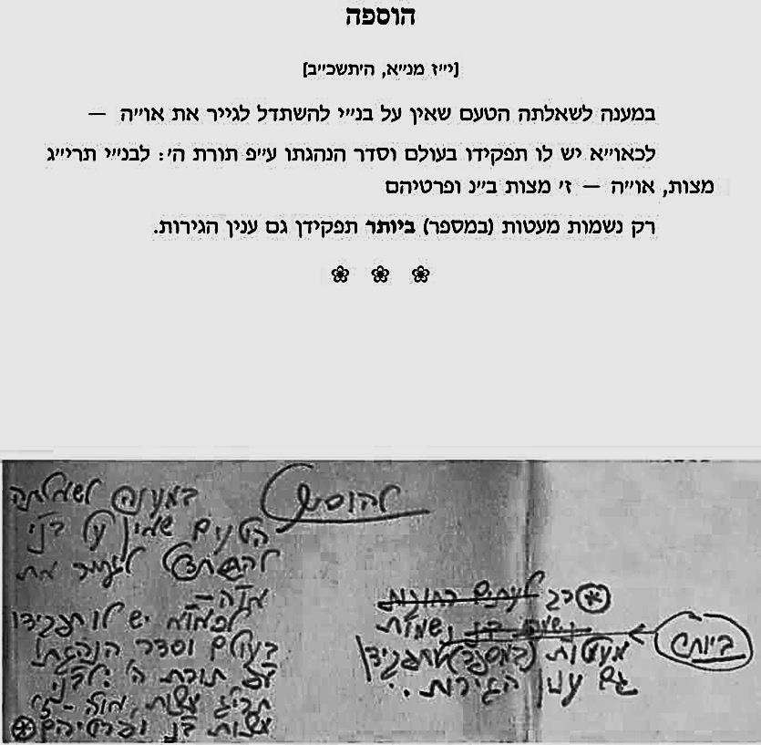 (The letter was printed in Kfar Chabad magazine, issue 1777, and what appears here is a translation from a Hebrew version of the original letter).

**The Rebbe’s handwritten responsum**:

“In answer to her question of why the Jewish people are not obligated in converting Gentiles: Each individual has a purpose in this world and a measured way [of reaching that purpose] in accord with Hashem’s Torah. The Jewish people have the 613 *mitzvos*; Gentiles have the seven Noachide laws and their specifications. Yet [of the Gentiles] it is only an **extremely** small number of souls whose purpose is also conversion.”

The disastrous consequences of intermarriage

Blessings and Greetings,

I received your letter in which you bring up the subject of mixed marriages, may G-d protect us. Even though a great deal has already been said, written and published about the terrible disaster of mixed marriages between a Jew and a non-Jew, and most of it is very clear and obvious; nevertheless, due to the seriousness of the matter, I will in short review a few of the most basic points.

I don’t have to tell you that any matter involving a Jew needs to be examined first of all from the perspective of the Torah, since our Torah, which is a law of life, is the guide for the Jew in his life and also the source of his life, not only in this world but also in the world to come.

Nevertheless, since I don’t know to what extent the person in question will understand the importance of the Torah’s perspective, and since I have the impression that it would be more useful to speak in terms of general human terms rather than religious ones, I will take that approach.

1. Statistics have proven in sufficient measure that intermarriage is one of the biggest catastrophes among people, not only for the Jewish spouse, but also for the second side involved. Since the two individuals come from such different backgrounds, a mixed marriage can lead to constant quarrelling and heartache, and the tragedy is even greater if there are children to grow up in the future in a household that is torn apart by such frictions.

Moreover, the statistics show only the “tip of the iceberg,” since many tragic cases go unreported and nor do they attract the attention of the public, since the sides involved are very much ashamed to admit that they made such a major mistake. This is especially true in cases when they were warned about the consequences, and they preferred to ignore the warnings.

2. The statistics are not that surprising. In fact, it would be very surprising if the results were otherwise, when contemplating the fact that the two people come from origins and backgrounds that are not only different, as mentioned above, but also from antagonistic background, generations upon generations of persecution from one side, and victims from the other side.

3. One of most common arguments for defending the “justice” and the “freedom” concerning mixed marriages is that since both sides are adults, and they are prepared to accept the consequences etc., no one has a right to interfere and hinder them.

One single simple example is enough to show the error of this claim: consider a case in which a person is standing on a bridge and wants to jump off in order to end his life. He claims that he knows what he wants to do, and that no one has a right to interfere etc. It is obvious that in any civilized society, everyone in the vicinity would be obligated to try to stop that individual from carrying out his intentions. If necessary, the police department and the fire department would be summoned to prevent the possible suicide and use every possible means to save him from hurting himself.

4. If the two people involved have true feelings, not to mention a sense of simple fairness and honesty, then neither of them would want to get the other person involved in such a predicament, even if the risks were very slight. In fact, however, as already pointed out, the concerns are very realistic and it is practically unavoidable that the mixed marriages have to end in disaster, both in the material and spiritual sense. Even if there are a few couples like these who appear to be happy and satisfied etc., it is very likely that this is no more than an external impression they wish to convey, because they do not want their inner discomfiture to be known to the public.

Much more could be said about all this, but I trust that this will definitely be sufficient.

I would just like to add that from a religious point of view, in terms of Jewish obligations and Jewish identity, intermarriage is one of the most serious sins, affecting the whole life.

Moreover, although everything we have said is relevant to all the generations, it is even more true and more important in our own time, since the Holocaust has left us with a special legacy: it places an obligation upon all the Jews who survived to ensure that such a thing will never happen again. There are two methods by which our enemies attempt to destroy the Jewish people. One is by physical annihilation, which is what the Nazis, may their names be obliterated, tried to do. The other method, which is more sophisticated but no less catastrophic, is through assimilation, and especially through mixed marriages, may G-d protect us.

If so, a Jewish man who marries a non-Jewish woman, in addition to the destruction he brings upon himself and his partner, he also brings destruction upon the descendants, because the children who are born to a non-Jewish mother are not Jewish.

With blessings,

(The letter was printed in Kfar Chabad magazine, issue 1210, and what appears here is a translation from a Hebrew version of the original letter).

1. (I wrote down his words and Rabbi Slavaticki corrected).
2. *Hitvaaduyot* 5745, vol. 2, P. 1042-1045.
3. A Happy Home – The Lubavitcher Rebbe on Marital Harmony, pp.379-380.
4. Igros Kodesh, vol. 27, p. 436.
5. Bamidbar, 23:9.